Note to project sponsors: It is our experience that the more detailed this “Project Brief” the smoother the project will run and the greater the value you will get out of the end product as a project sponsor.

Project Title: Data Analytics through Visualization @ PayPocket
Background: Any relevant information on the mentor’s business, the business problem, prior analyses, and links to known business and/or academic literature.
You are working for a startup (PayPocket) who needs to configure a name verification service. PayPocket offers a service to retailers to add to their customers as a value add. The service provides customers of the retailer active price matching on all products purchased from the retailer. The retailer offers this service to the customer at checkout. If the customer opts-in to the service, PayPocket scans for a lower price for 30 days. If PayPocket finds a lower price, PayPocket initiates a payout to the customer for the difference. When the customer purchases the item online, the retailer collects your email, first name, middle name (optional), and last name plus certain characteristics of the purchase (discussed in more detail below) and shares the information with PayPocket. The payment method is not shared with PayPocket due to data privacy restrictions. To receive a payout from PayPocket, the consumer logs in to the PayPocket site to claim the payout. When the consumer logs in and initiates the payout, the customer sets-up a payout account (checking, PayPal, Zelle) to receive their rebate.
Project Overview and Problem Definition: The problem definition has to be complex enough to merit the usage of advanced analytical techniques. At the same time, the scope of the problem has to be constrained in a way that allows it to be well addressed by the assigned student team during the last several months of their studies. Background specific to the project.
Your company needs data analytics to understand the flow and characteristics of the payouts. The team must use standard, existing libraries to visualize items like the velocity and volume of payments; where geographically payments are being made; what types of accounts are receiving payouts; and any other visualizations/analytics you feel would be value added. Below are sketches of visualizations that came out of an ideation session held at PayPocket prior to you coming on board. You are not bound by these ideas but are rather provided to give you a better idea of the background.

Ideation session / wireframes:
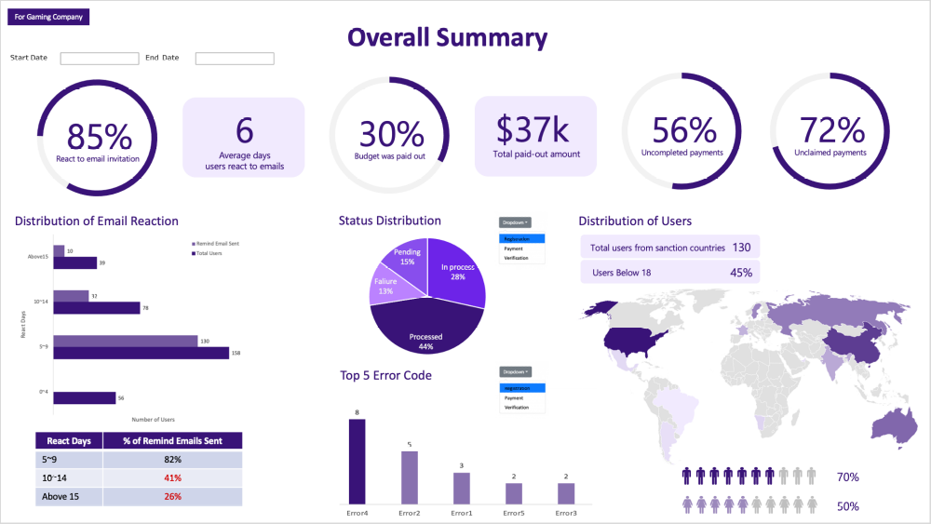
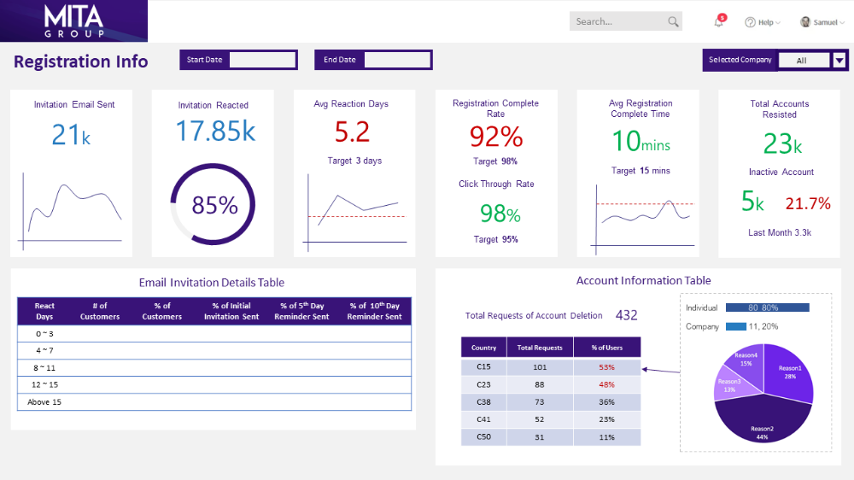

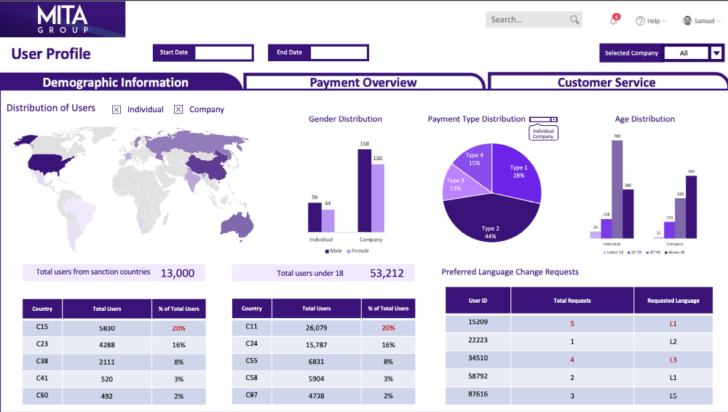

Project Goals: Clearly identified project critical success factors to indicate clear project success.
- Use Python or other open-source alternatives to develop visulatizations that provide insights as described above
- Use existing libraries for analytics and display them in a dashboard so that a non-technical user can glean insights
Potential Roadblocks and Barriers to Success: Based on prior attempts at this project, what were known barriers? These could include access to data, inadequate analytical capabilities, or compute capacity.
Acquiring enough data understanding to create synthetic data to formulate impactful visualizations and analytics.
Preferred Methodology: Based on the mentor’s understanding of the problem, is there a vision for the data or analytics methodology, such as CRISP-DM or Agile Development Sprints.
CRISP-DM
Data Requirements and Availability: Will the project sponsor be providing some or all of the data or will the team need to acquire data. Will the project sponsor be providing a budget for data acquisition if necessary.
A data model will be provided. The students will be required to develop synthetic data to populate the data model.
Analytics requirements: The project sponsor’s vision with regard to the type of analytics to solve the problem. For example, advanced structured analytics, machine learning, natural language processing.
EDA: Pandas describe() function for basic descriptive statistics to determine what (if any) data cleaning is necessary to complete the Data Understanding phase
Visulaizations such as Geopandas, shapely, matplotlib.
ML to build in some predictive analytics to layer on top of the historical data shown in the dashboard.
Preferred Tooling: The team will be providing the project sponsor with all data, visualizations, and program code. Does the project sponsor have a preference on the project tooling, for example, R versus Python.
Python. All students should install Anaconda. Anaconda will automatically install Python 3 on any OS.
Project Schedule: Below the template class schedule with regard to project completion and sponsor interaction.
Data Collection: 2 weeks
Data Analysis/Modeling: 2 weeks
Prepare/present findings: 1 week

